**TECHINCAL REPORT ON STUDENT INDUSTRIAL WORK EXPERIENCE SCHEME (SIWES)**

**UNDERTAKE AT**

**HM DOMBO TECHNOLOGIES,**

**MAYO BELWA, ADAMAWA STATE**

**FROM: 4TH JANUARY, 2023**

**TO: 4TH MAY, 2023**

**BY**

**ABUBAKAR MUHAMMAD**

**ST/CS/ND/21/040**

**SUBMITTED TO**

**THE DEPARTMENT OF COMPUTER SCIENCE**

**SCHOOL OF SCIENCE AND TECHNOLOGY**

**FEDERAL POLYTECHNIC MUBI**

**IN PARTIAL FULFILLMENT FOR THE AWARD OF NATIONAL DIPLOMA (ND) IN COMPUTER SCIENCE**

**JUNE, 2023**

**DEDICATION**

This report is dedicated to Almighty God whose guidance and wisdom make this report a reality and also to my loving parents and brothers for their support.

**ACKNOWLEDGEMENTS**

First of all, my sincere thanks and gratitude goes to Almighty God who through His guidance gave me the energy to conceive this report. I wish to extend my profound gratitude to my families, friends and well-wishers who supported me financially in all aspects during my industrial Training. I will also like to appreciate Mr. **Hamidu M Dembo**

**ABSTRACT**

This report is based on the student industrial work experience scheme (SIWES undertake at **hm Dembo Technologies** located at Tashan Gengle, Mayo Belwa Local Government Area of Adamawa State. It provides a brief explanation about the SIWES program such as it history, objectives, aims while also giving a description of the work done in **hm Dembo Technologies.** It further focuses on the technical exposure gained from each department, and training department. It finally gives account to some of the machine and equipment used in the various departments as well as it functions. It also provides insight in some of the challenges faced and gives a few recommendations on how to further improve the program.

**TABLE OF CONTENT**

Title page - - - - - - - - - - i

Dedication - - - - - - - - - - ii

Acknowledgment - - - - - - - - - iii

Abstract - - - - - - - - - - iv

Table of Content - - - - - - - - - v

**CHAPTER ONE**

1. INTRODUCTION - - - - - - - - 1

1.1 THE SCOPE OF SIWES - - - - - - - - 1

* 1. AIM AND OBJECTIVES OF SIWES - - - - - - 1
  2. RESONS WHY SIWES WAS ESTABLISHED - - - - 2
  3. BACKGROUND OF THE SIWES - - - - - - 2

1.5 SUCCESS RECORED BY SIWES - - - - - - 2

**CHAPTER TWO**

2.0 SIWES WORKPLACE - - - - - - - - 4

2.1 BRIEF HISTORY OF HM DEMBO TECHNOLOGIES - - - 4

2.2 SERVICE RENDERED BY HM DEMBO TECHNOLOGIES - - - 4

2.3 ORGANIZATIONAL STRUCTURE/CHART - - - - - 4

**CHAPTER THREE**

3.1 DEPARTMENT IN HM DEMBO TECHNOLOGIES - - - - 5

3.2 WORKING EXPERIENCE FROM VATIOUS DEPARTMENTS - - 5

**3.3** INTRODUCTION TO MICROSOFT WORD - - - - - 5

**3.4** INTRODUCTION TO MICROSOFT POWERPOINT - - - - 6

**CHAPTER FOUR**

4.1 DESCRIBING MICROSOFT EXCEL ENVIRONMENT - - - 7

**CHAPTER FOUR FIVE (5)**

4.1 SUMMARY - - - - - - - - - 9

4.2 CONCLUSION - - - - - - - - - 9

4.3 RECOMMENDATION - - - - - - - - 9

REFRENCES - - - - - - - - - - 10

**Chapter One**

**1.0 Introduction**

The Student Industrial Work Experience Scheme (SIWES) is an accepted skill training scheme which from part of the approved minimum academy standards in various degree scheme for all Nigerian universities and polytechnics to acquire industrial skills and experience in their various course of study.

**1.1 Scope of SIWES**

The scheme is aimed at bridging the existing gap between theory and practice of Sciences, Agriculture, Medical Sciences (including Nursing), Engineering and Technology, Management, Information and communication technology, and other professional educational programs in the Nigerian tertiary institutions.

**1.3 Aim and Objectives of SIWES**

1. Provide an avenue for student in institutions of higher learning to acquire industrial skills and experience in their approved course or study and also by interacting with people with more experience in the field under consideration.
2. Prepare students for the industrial work situation which they are likely to meet after graduation.
3. Expose student to work methods and techniques in handling equipment and machinery that are mostly not available in their various institutions.
4. Provide student with an opportunity to apply their knowledge real world situation thereby reducing the gap between theoretical knowledge and practical work.
5. Enlist and strengthen employer’s involvement in the enter educational process and prepare student for employment in Industry and commerce

**1.4 Reasons Why SIWES Was Established**

SIWES was established by Industrial Training Fund (ITF) in 1973 to solve the problem of lack of adequate practical skills preparatory for employment in industries by Nigerian graduates or tertiary institutions.

**1.5 Background of the SIWES**

The Student Industrial Work Experience Scheme (SIWES) was established in 1973, the scheme is a scheme involving student, the higher institution and the industry (employer) .it is funded by the federal government of Nigeria and jointly coordinated by the Industrial Training Found (ITF) and the National Universities Commission (NUC). This training scheme is also an effort to budge the gap existing between theory and practice of Engineering, Science, Agriculture, Management and other professional educational programs in Nigerian tertiary institution.

**1.6 Success Recorded by SIWES**

The scheme has recorded tremendous since its creation among which are:

1. It has been able to restore students, making them assumed their competence.
2. It has also help student get acquitted to the method of the various career.
3. SIWES enhance the competency of student in their academic activities, prepares them for future job challenges and creates employment opportunities.
4. It had helped student by exposing them to practical knowledge of things they were taught in the classroom.

**Chapter Two**

**2.0 SIWES Workplace**

My SIWES program was undertaken at **hm Dembo Technologies.** located at Tashan Gengle, Mayo-Belwa, Local Government Area, Adamawa State.

**2.1 Brief History OF hm Dembo Technologies**

Hm Dembo Technologies was established on 2014 with are Desktop computer, one LaserJet printer, one Generator and one staff.

We commend a certificate training on computer application with 14 students in the 2020 with enough practical facility and 6 staff, 4 facilitators and are security man.

**2.2 Service Rendered by hm Dembo Technologies**

The services rendered in **hm Dembo Technologies** are: -

**Computer Training:**

1. Computer Maintenance
2. Online Registration
3. General Printing
4. Sales of Computer Accessories

**2.3 Organizational Structure**

MANAGER

OPERATOR

STAFF

TRAINERS

Figure 1: Organizational Chart

**Chapter Three**

* 1. **Department in** **hm Dembo Technologies are as follow:**

1. Graphic Designing Department
2. Business Centre Department
3. Computer Training Department

**3.2 Working Experience from Various Departments**

In the course of my **SIWES,** I was exposed to a lot of things about computer from some of the department in **hm Dembo Technologies.** The experience and training which I receive from these departments are as follow;

**Graphic Design Department**

This Department are in charge of Graphic design, they make use of high-class software such as, print-artist, CorelDraw, which designs are been made. With the help of this SIWES program, I have been exposed to all this software and how to use them in carrying out graphic design such as: NNPC Logo, Invitation card, cover pages, weeding cards etc.

**Business Centre Department**

This department involve in doing photocopy, Printing of hard copy, filling of online form e.g. Air force, Navy, and other force branches, creating of letter heading paper, installation of software application, typing text document and computer repair. Also designing of; banner, business card, cash receipt etc.

**Computer Training Department**

This department is the one for the training of student about the computer aspect concerning the software, and how to make use of some application to accomplish specific task which serve as the act of impacting knowledge to those who are interested to learn about the computer. This department helps to educate the trainers or leaner’s in to the present technology of the system and also been self-reliance.

**3.3 Introduction to Microsoft Word**

Microsoft word is the typing, editing, storing, and printing of texts through an electrochemical device called computer. It can also be defined as the act of manipulation characters to create a professional looking document through the computer.

**Some important keywords in the definition**

1. **Typing:** This is done by using the keyboard. The keyboard is it is known as input device. It has about 108 keys on it. There are five part of the keyboard namely: function keys e.g. f1-f12, computer keys e.g. Esc, ctrl, shift, etc. Typing keys A-Z, Dedicating keys e.g. page up, page down, Arrow keys and Numeric keypad.
2. **Editing:** This is type act of correcting error (s) in a document. It is also involves rearranging the document so as to give a perfect, desire, and professional.
3. **Storing:** this is the same thing as saving a document into the permanent memory so as to able to re-call it any other time. It is needed. This should always be done frequently so as to guide against frequently power failure which can shut down the computer and erase any file that has not been saved.
4. **Printing:** This is the act of getting the hard copy or the soft copy of the document through a device called a printer using paper.

**3.4 INTRODUCTION TO MICROSOFT POWERPOINT**

Microsoft PowerPoint is software which is included in the Microsoft Office suite that is very commonly used to create presentations for business settings. PowerPoint can make presentation easier to understand and more interesting, it can also be misused bad PowerPoint presentations can make people dread meetings.

**Definition of Microsoft PowerPoint**

Microsoft PowerPoint is software designed to integrate grouping text into striking high impact presentations. Presentation are projected onto a screen for viewing by several people within a room by using an overhead projector connected to a computer PowerPoint. Stores its files format, with each file being comprised of what is known as presentation. Each presentation includes notes which are not display on the projec5tion screen, but which can serve as prompts for the presenter.

**Importance of Microsoft PowerPoint**

PowerPoint presentations are a way of attracting audience towards your views and arguments. It is one of the most helping factors behind success of every meeting. There is various user of PowerPoint presentations are in modern days learning, corporal training sessions, business and marketing meetings, and sales gatherings.

**3.5 MICROSOFT EXCEL ENVIRONMENT**

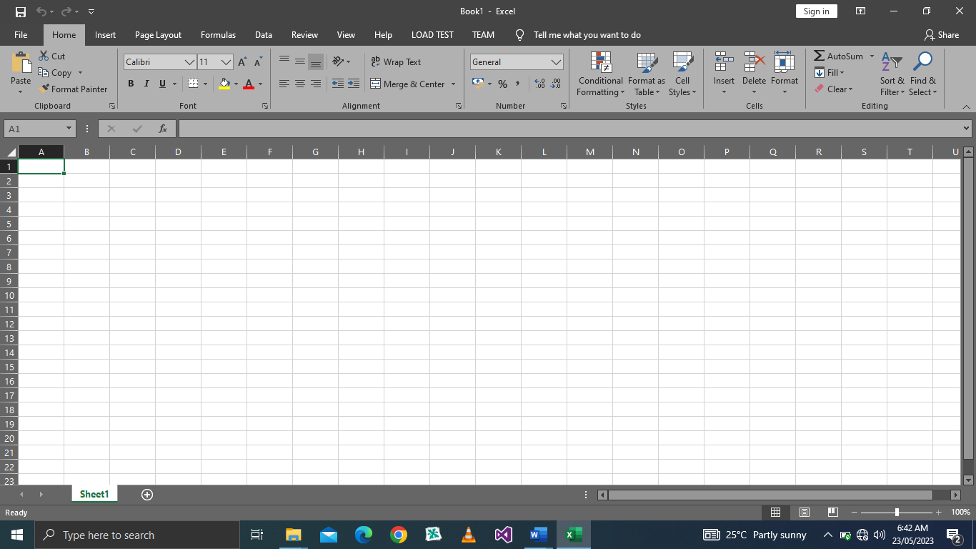

Figure 3.2: Microsoft Excel Interface

When Microsoft Excel is fully loaded into the computer memory, the following will be seen.

1. The spreadsheet/worksheet
2. Rows, Columns and cells
3. The mouse pointer and cursor
4. Working menu and bars

**HOW TO CACULATE SUM**

We use sum when calculating addition in excel. And before spreadsheet can respond to any mathematical command. It must be entered as an equation. Therefore, to enter a function as an equation. We must firstly start with ‘‘equals to’’ (=) sign.

Steps in calculating sum:

1. Firstly, the data must be entered correctly as shown below
2. Then keep your cursor on the location you want sum to be displayed by clicking the mouse there
3. Type =sum and open bracket ‘‘(then, click the mouse on the first cell you want to sum now type: click mouse on the last cell containing the data to be sum
4. Then close the bracket)
5. Press enters on the keyboard.

**INSERTING ROWS AND COLUMN**

In case you need to type a given line of data in a given rows and column, but discover it has been occupied by another data not worry, you can simply insert another row or column in the same place.

Step in inserting rows and column:

1. Keep your cursor where you want the row or column
2. Click on insert on the menu bar
3. On the submenu displayed, click on either row or column depending on your choice.

**INSERTING ROWS AND COLUMN**

In case you need to type a given line of data in a given rows and column, but discover it has been occupied by another data not worry, you can simply insert another row or column in the same place.

Step in inserting rows and column:

* Keep your cursor where you want the row or column
* Click on insert on the menu bar
* On the submenu displayed, click on either row or column depending on your choice.

**CHAPTER FOUR**

**SUMMARY, CONCLUSION AND RECOMMENDATIONS**

**4.1 SUMMARY**

The whole experience gained during the attachment at **hm Dembo Technologies** was very enlightening. The practical skills we were exposed to the opportunity to relate with typical situation relating to computer services. These experiences have successfully broadened my understanding and interest in computer service as profession especially in the field of computer maintenance. the training was worth willed, has it accorded me the privilege of gaining insight into job preparation as well as what it means to carry out proper injection and also working condition under stress which is prepares undergraduates for the outside world after school.

The program gave me the privilege to relate with senior professionals and other students from different institutions and the experience made appreciate the nature, benefits, and intricacies of my chosen field of study both in the classroom and in the society at large while also give me the opportunity to put into practice the theoretical knowledge acquired throughout my stay in school.

**4.2 CONCULSION**

The scheme has impacted knowledge in **hm Dembo Technologies**, I have experienced what it feels to practice the hardware and software part of the computer as a profession and I have achieved the aim of objective of this scheme. I seize this medium to advice any situation to take this four (4) month training serious.

The aim of objective of this scheme. I seize this medium to advice any situation to take this four (4) month training serious.

**4.3 RECOMMEDATIONS**

I like to use this medium to explore the Federal Government at all stage to take SIWES program more seriously seen by the students of applied science as virtual improvement in future of technology in our nature.

Government should also ensure a proper supervision of SIWES student so that purpose of the program will achieve.

The Federal Government should make adequate provision in the annual budget for funding of SIWES in the view of the potential of scheme to contribute to enhancing the quality of the technical skill available to the economy.

A comprehensive and detail directory of employer who accept student in industry.

In order to guarantee quality assurance of institution and the ITF, the ITF should that backlog in payment student allowance is cleared urgently to remove the negative image being created for SIWES.